**Voltage conditioning circuit**



The supply of 230 V is given to differential op amp with -ve feedback configuration , Rf = 20 K ohm ,Ri = 4 M ohm .the floating point voltage is provided by potentiometer by giving connection between +15V of supply and Ground to give 2.5V ,this is given at +ve terminal with a resistance of 20 k ohm to from a differential op amp circuit to convert it into a range of 0-5 v for Arduino .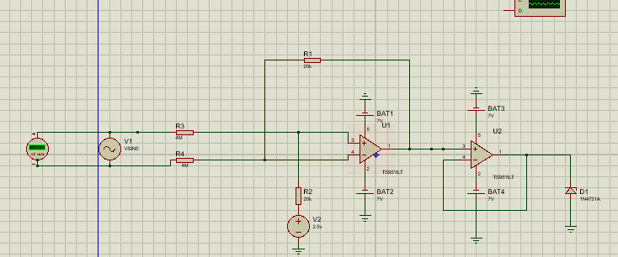

1 ) When floating point voltage (2.5 V DC ) is absent only when 230 v input is given it forms

= +1.65v

Gain for above differential amplifier (1/200)

2) when supply is not given then it behaves as non-inverting ckt so output voltage is given as

$(V0 =Vin \frac{Rf}{Ri})$ while the virtual short where the -ve terminal here 2.5 v it divided between the 20k and 4m at +ve terminal $2.487 =2.5 \frac{4M}{4M+20K}$

and it which is approx. 2.5 v by virtual short at -ve terminal the voltage is 2.5 v it again causes a current to flow which through 4M ohm resistor (If) from ground to -ve terminal and then from feedback to output .by kvl loop in the feedback which gives Vo = 2.5 v

Vo= 2.4875 + If *20K = 2.5 , If =

So by super position theorem we can say that the output is + 1.65v + 2.5 v which is in the range of

0-5 V which can used for Arduino supply

CURRENT SENSING

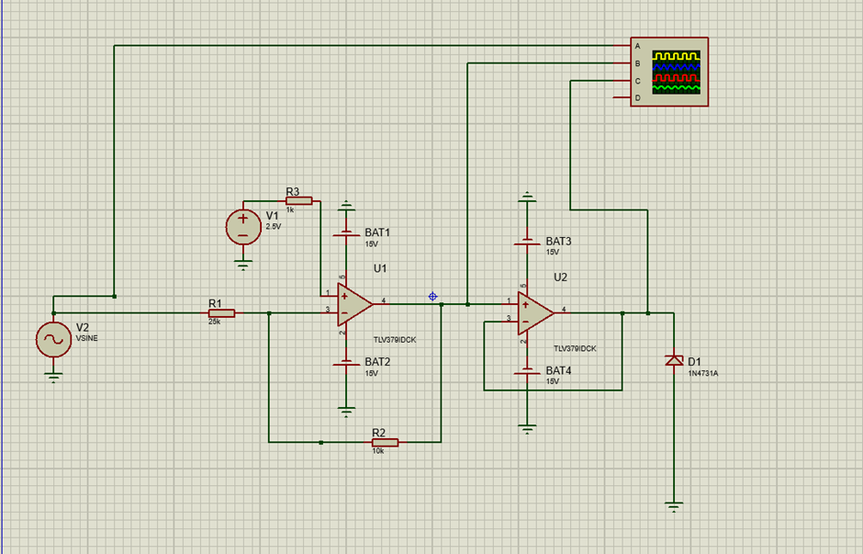

For the current sensing part the input given is 5ma AC. as the Arduino takes the input in terms of voltage we will connect a resistor of 300 ohms to get in terms of voltage. As the current is ac so the resultant voltage is also ac which has both positive and negative values.to get into the range of arduino i.e (0-5v).we have to upshift the negative part and reduce into operating range of Arduino. So we wiil use a Inverting op amp to get the desired values

In the inverting op amp the Input is given in to the inverting terminal and the input resistance Rin.and A Negative Feedback with Feedback Resistance Rf. we add an offset of 2.5v in the non inverting terminal to get the upshift. The Mathematical Expression for the Vout is described below

We can find the Vout by using Nodal Analysis as we know the property of op amp is Virtually grounding property as we are giving an offset of 2.5v in Non inverting side That voltage will appear in the Inverting terminal also by Applying Nodal Analysis we Get the required output of the op amp

NODAL ANALYSIS

-(2.5-vin)/Rin = 2.5-vout\Rf

By simplifying the above equation we get

Vout=Vin(-Rf/Rin)+2.5(Rf+Rin/Rin)

If 2.5V Offset is not Added the output is simple inverting op amp output

Vout=Vin(-Rf/Rin) By using this we get the Negative part of the Volatge also which is not meeting Arduino Requirments. So the 2.5 Offset must be added

Here In our Simulation

We Taken Vin=2V Ac , Rf=10K ohm, Rin=25K Ohm,

So by putting the Values we got an output Ranging from 2.7 to 4.3V which is in range of Arduino